**IBM- Naan mudhalvan Data Analytics with Congnos**

**Student Name :** Badhrinathan N

**Register Number :** 620821104015

**Branch** **:** B.E CSE

**Year**  **:** 3rd year

**Topic :** Data Analytics with Cognous

**Title :** Web Traffic Analysis

**College :** Gnanamani College of Technology

**Web Traffic Analysis**

**Abstract:**

In today's digital age, understanding web traffic patterns is crucial for businesses and organizations to optimize their online presence and user experience. This abstract presents a comprehensive framework for web traffic analysis, highlighting the importance of design thinking principles in problem definition and the integration of Python for efficient data collection and visualization.

## Introduction

Web traffic analysis involves the use of machine learning models to gain insights into website user behavior, predict future traffic trends, and optimize various aspects of web content and infrastructure. This document explores the machine learning models commonly used in web traffic analysis and considerations for incorporating these models into data analytics with Cognos.

**Understanding the Problem:**

Lots of data is created when people visit websites. The tricky part is turning all that data into useful information. This problem is about making sense of the data to make websites better for users.

**Design Thinking:**

Design thinking is a human-centered approach that focuses on empathy, ideation, and iteration to solve complex problems. In the context of web traffic analysis, design thinking helps us define the problem by empathizing with users, identifying pain points, and ideating solutions that enhance the user experience. This methodology ensures that the analysis process remains user-centric and goal-oriented, ultimately leading to meaningful insights.

**Project Definition:**

**Analysis Objective:**

The primary objective of this project is to enhance web traffic analysis by employing design thinking principles to define the problem and leveraging Python for efficient data collection and visualization.

**Data Collection:**

Data collection is a critical aspect of web traffic analysis. We will explore various data sources, such as web server logs, Google Analytics, and user surveys, to gather comprehensive information about user interactions, demographics, and preferences. Python will be used to automate data retrieval and preprocessing, ensuring a streamlined and error-free data collection process.

**Visualization:**

Data can be hard to understand. We'll use Python to make cool charts and graphs that show us the important stuff. This will help us see what's working and what needs improvement.

**Python Integration:**

Python is a handy tool that will help us with many parts of this project. We'll use it to bring data together, make it clean and organized, and create easy-to-understand pictures from the data.

## Common Machine Learning Models in Web Traffic Analysis

### 1. Regression Models

* Linear Regression
* Polynomial Regression
* Logistic Regression
* Purpose: Predict web traffic volume, conversion rates, and numerical metrics.

### 2. Classification Models

* Decision Trees
* Random Forests
* Support Vector Machines (SVMs)
* Purpose: Identify malicious traffic, categorize user behavior, and classify user interactions.

### 3. Clustering Models

* K-Means Clustering
* Hierarchical Clustering
* Purpose: Group users with similar behavior patterns for segmentation and personalization.

### 5. Ensemble Models

* Bagging (e.g., Random Forests)
* Boosting (e.g., AdaBoost, XGBoost)
* Purpose: Combine multiple models for more accurate predictions and robustness.

## Machine Learning Models with Cognos

## Step 1: Data Collection and Preparation

### Data Sources

* Identify and gather relevant data sources including web server logs, user interactions, historical traffic data, and any additional data required for analysis.

### Data Preprocessing

* Clean and preprocess the data:
  + Handle missing values.
  + Remove duplicates.
  + Normalize or scale numerical features.
  + Encode categorical variables.
  + Address outliers.

### **Data Integration**

* Integrate data sources into a unified data repository, ensuring data consistency and quality.

## Step 2: Feature Engineering

### Feature Selection

* Identify relevant features that can influence web traffic and user behavior, such as time-based features, user demographics, and content-related features.

### **Feature Engineering**

* Create new features or transform existing ones to capture meaningful patterns and insights.

## Step 3: Model Selection and Training

### Model Selection

* Choose machine learning models based on the nature of the problem:
  + Time series forecasting models for traffic trends.
  + Classification and clustering models for user behavior analysis.

### Model Training

* Train the selected models using historical data, splitting it into training and validation sets.
* Fine-tune model hyperparameters to optimize performance.
* Implement ensemble models for improved accuracy if needed.

## Step 4: Evaluation and Validation

### Model Evaluation

* Evaluate model performance using appropriate metrics:
  + For time series forecasting: RMSE, MAE, MAPE.
  + For classification: Accuracy, F1-score, ROC AUC.
  + For clustering: Silhouette score, Davies-Bouldin index.

### Validation

* Perform cross-validation to ensure model robustness.
* Validate results against ground truth data or user feedback.

## Step 5: Model Deployment

### Deployment Environment

* Set up a production environment for deploying machine learning models:
  + Choose cloud or on-premises infrastructure.
  + Ensure scalability and reliability.

### Integration with Web Analytics

* Integrate the machine learning models with web analytics tools, ensuring seamless data flow.

## Step 6: Monitoring and Maintenance

### Continuous Monitoring

* Implement monitoring systems to track model performance in real-time.
* Set up alerts for anomalies or deteriorating performance.

### Retraining

* Establish a retraining schedule to keep models up-to-date with changing web traffic patterns and user behavior.

## Step 7: Reporting and Visualization

### Dashboard Creation

* Develop interactive dashboards in tools like Cognos to present web traffic analysis results.
* Include visualizations for trends, user behavior insights, and predictions.

### Report Generation

* Generate regular reports for stakeholders, summarizing key findings, trends, and recommendations.

**Data source**

Dataset is collected from the kaggle.com named “daily-website-visitors.csv” which has a data about the Days, Day of week, Date, page Loads, Unique visits, First-time visits, Returning Visits.

Dataset link: <https://www.kaggle.com/datasets/bobnau/daily-website-visitors>

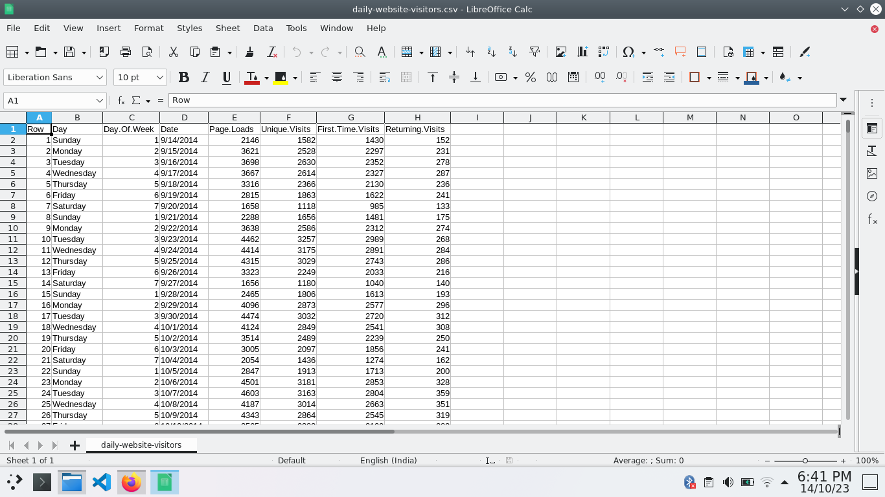

**Data Loading**

Steps Involved in data loading on IBM cognos.

* Login to your IBM cognos
* Click more menu from the left side
* Select new tab

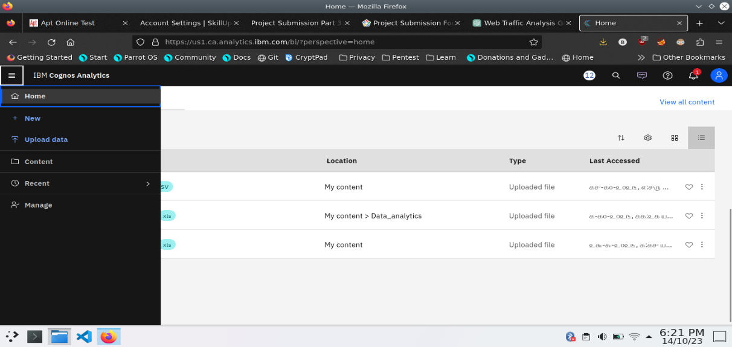

4. Click Data module tab

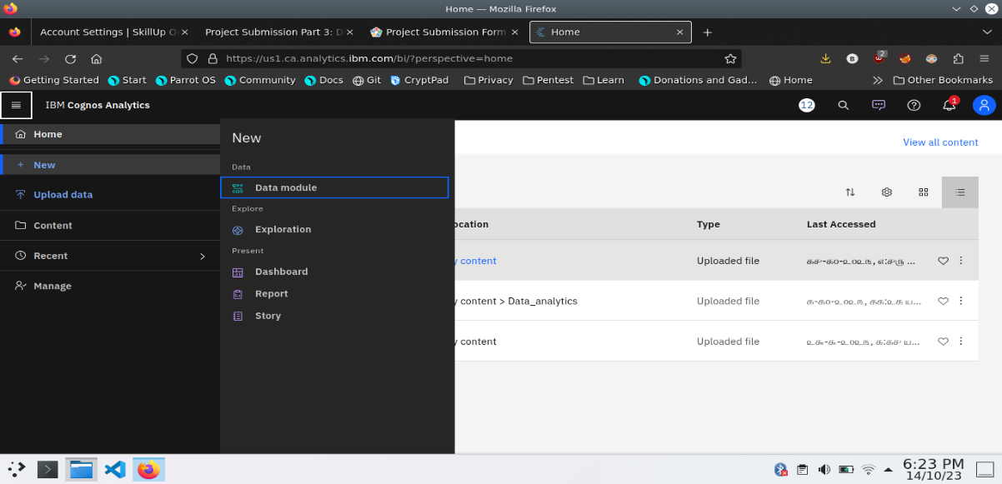

5.Upload the dataset for your project and select the Corresponding file

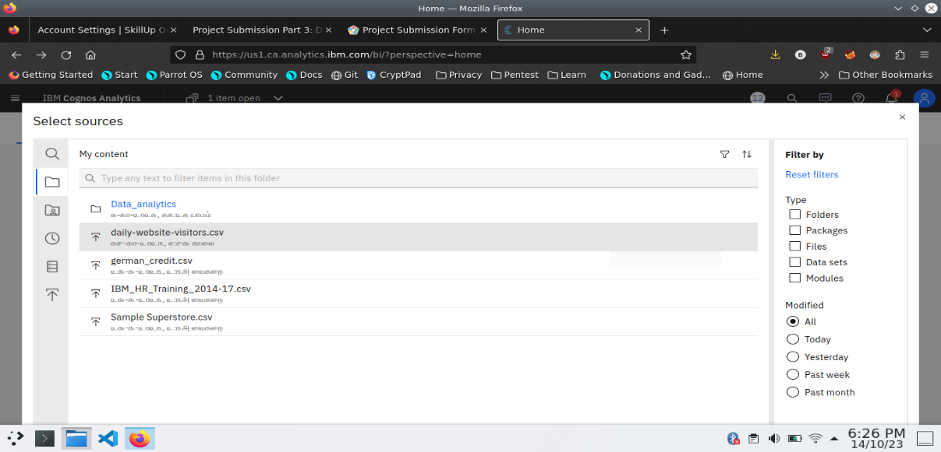

6. preview the data

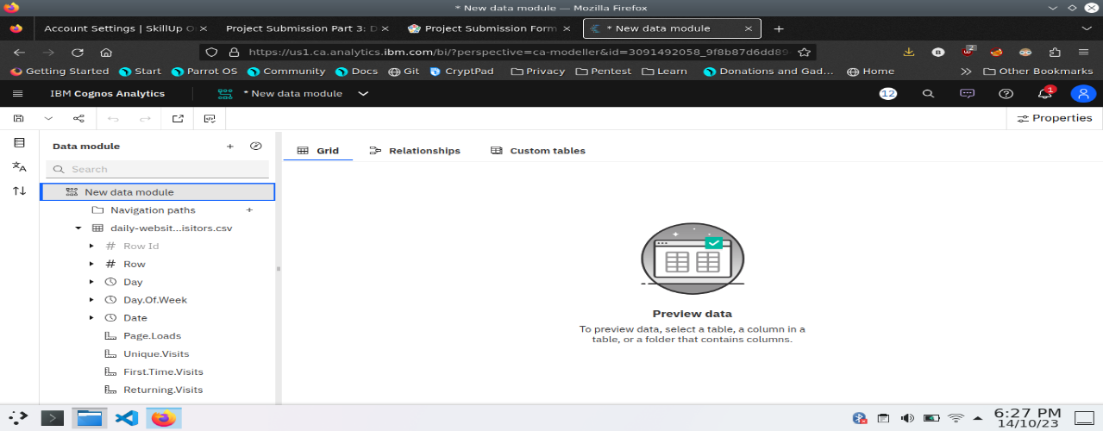

7.Explore the data

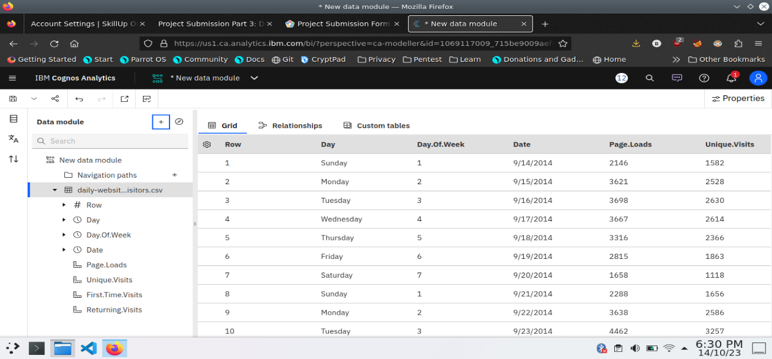

8. save the data module

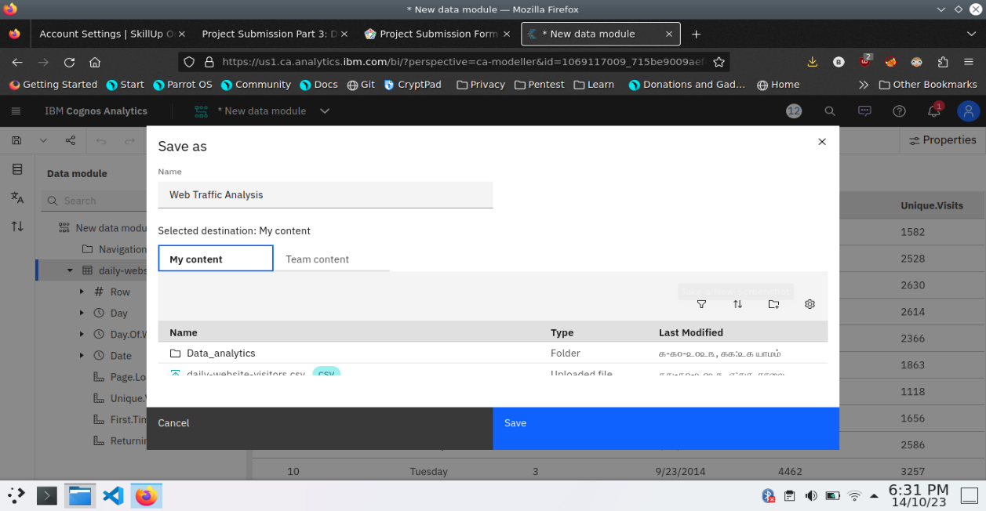

**Data Preprocessing and Cleaning**

In this phase the following steps will taken

* Handling missing data
* Data Transformation
* Data Type Conversion
* Removing Duplicates
* Dealing Outliers

Once you saved the data module. Click the corresponding dataset on IBM cognos and Preview the mosule

Right Click the row where you want to clean the data

It provides the UI to Clean the data and makes the task easy one, Now Updating and Replacing the Null values are simple

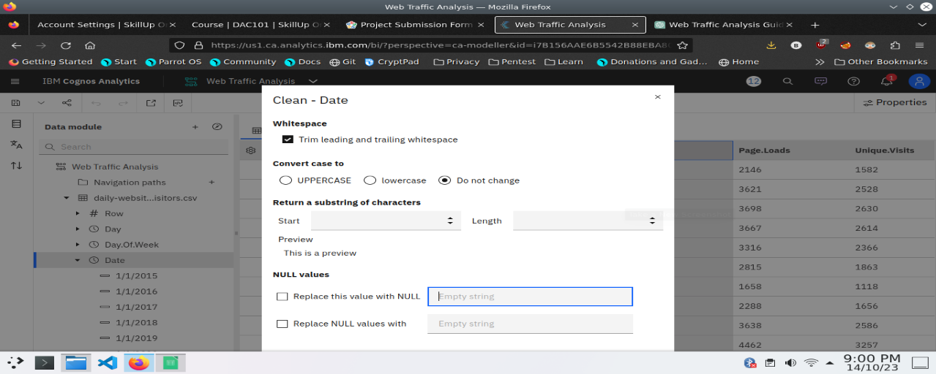

data module will be updated by doing the above process

after the completion of process start creating the dashboard for Visualization

**Dashboard Creation**

Dashboard creation are helpful to visualizing the data

* Goto Home menu
* Select the new tab
* Click dashboard

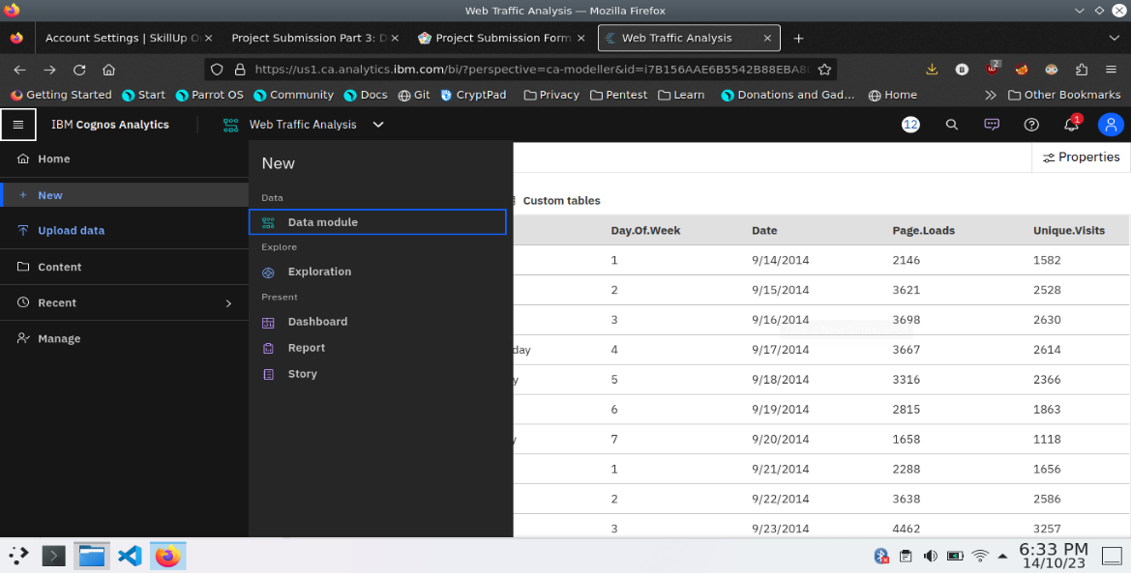

4. Choose the template for your project and click

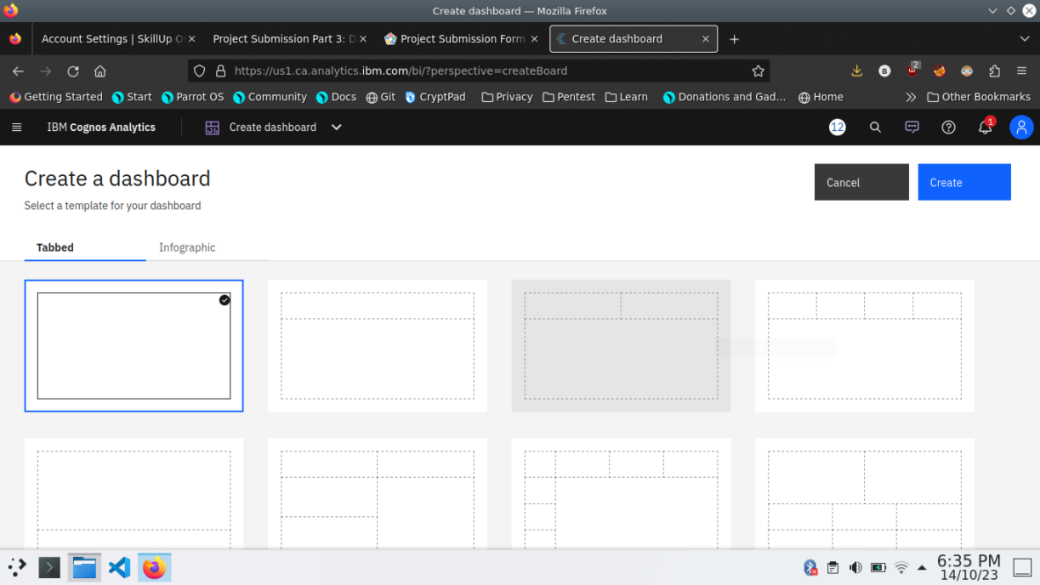

5.Now Dashboard is created

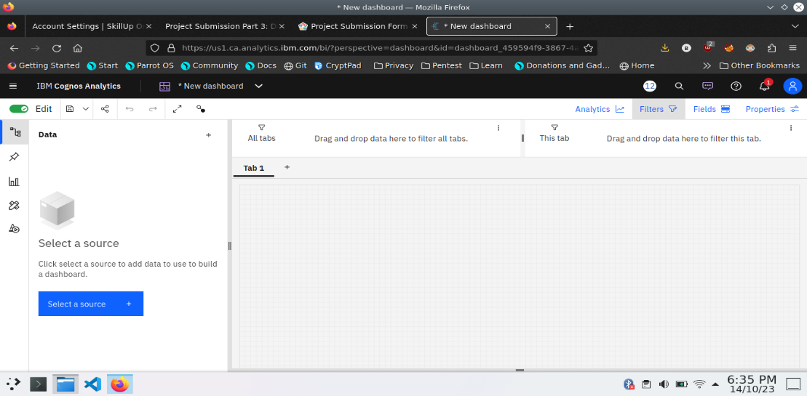

6. Select the data source

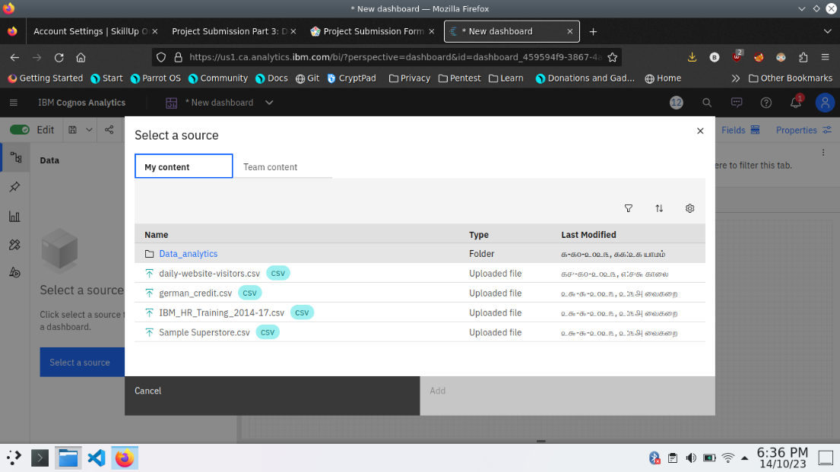

**Visualization**

After creating the dashboard, the next step is to visualize the data

In IBM Cognos

1. Goes to the Corresponding Dashboard

2. select the visualizations tab in the left side of title bar

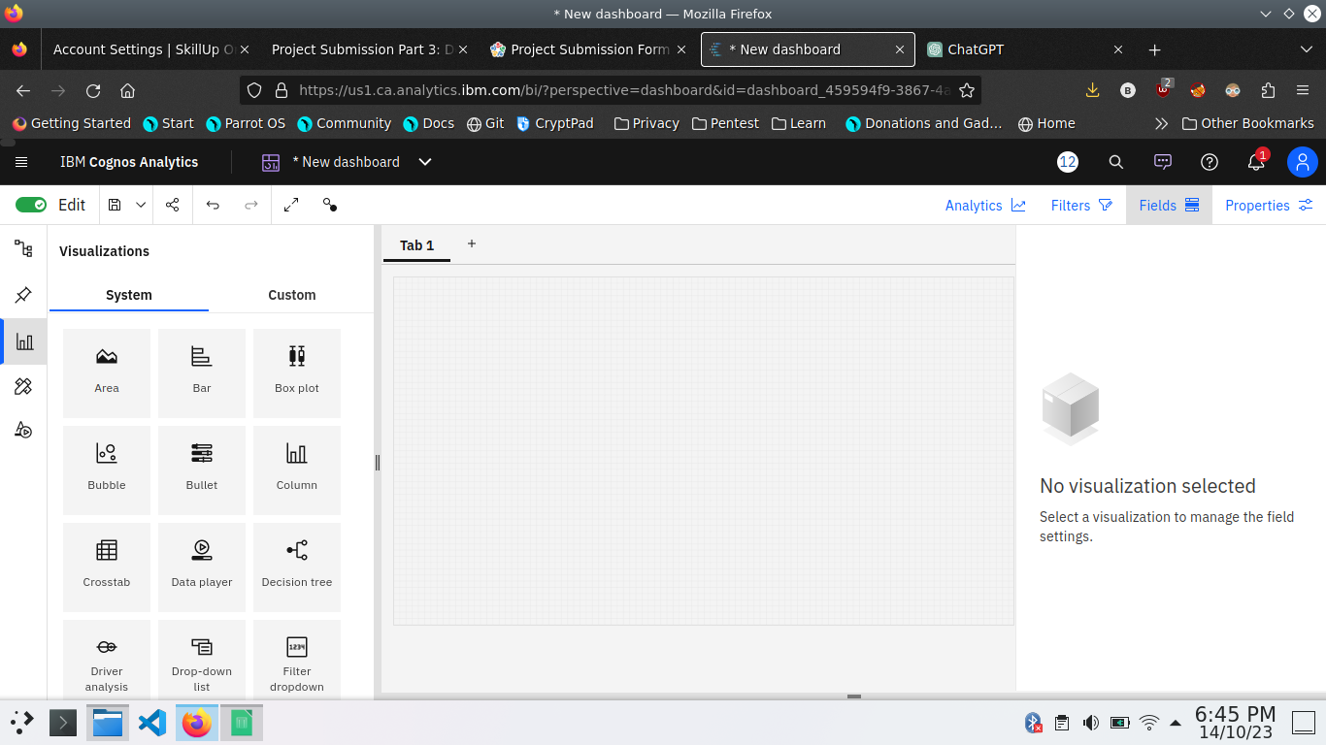

3.Choose the system as you want and put the data source for the required columns

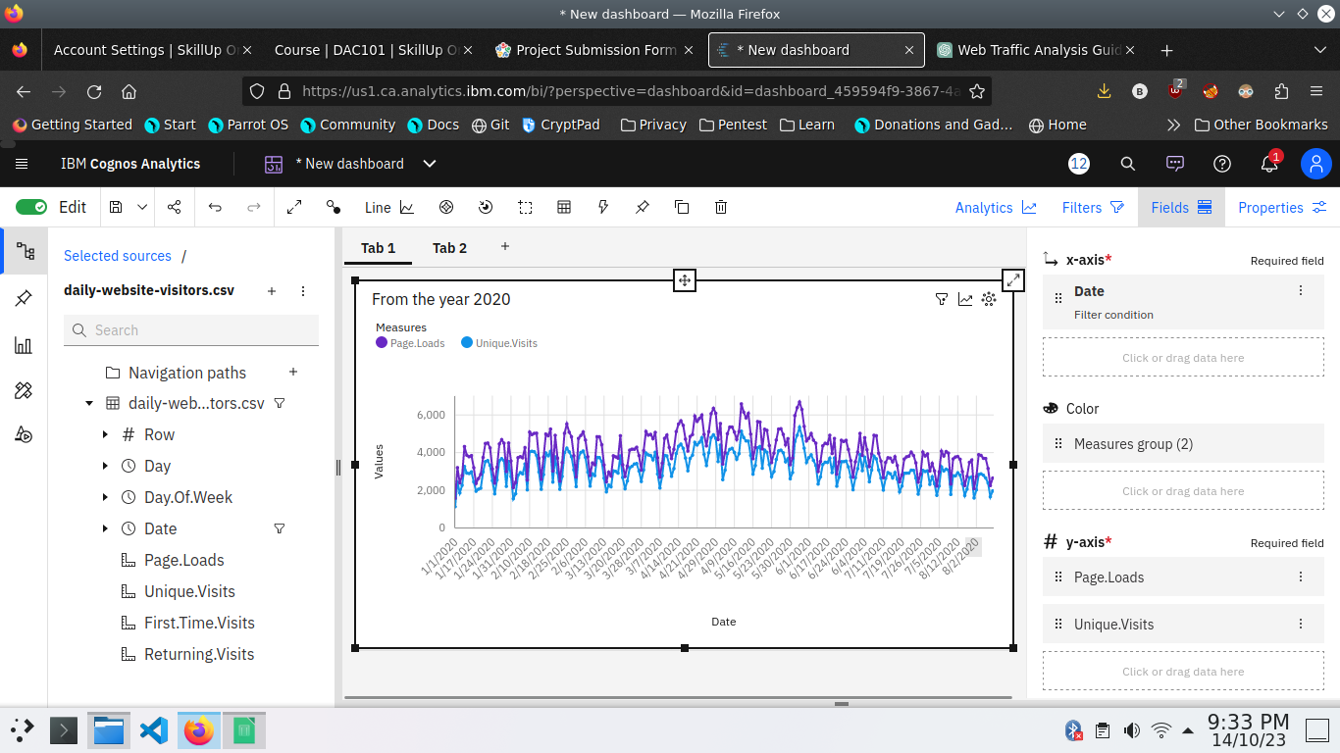

In the above screen shot displays the Line graph and model compares the “ Page.loads” and “Unique.visits” from the time period of 2020

X-axis =Dates

Y-axis = Page.Loads, Unique.visits.

**Barchart**

In this Bar chart the bars represent the ‘days in week’ and length defines ‘Page.Loads’

It helpful to visualize the maximum pageloads occurs on a day

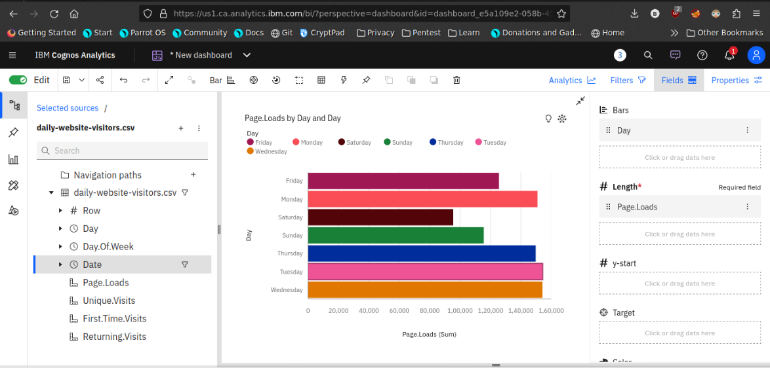

**Pie chart**

This is same as a bar chart. it helpful to analyze the Returing visits occurs on a particular day

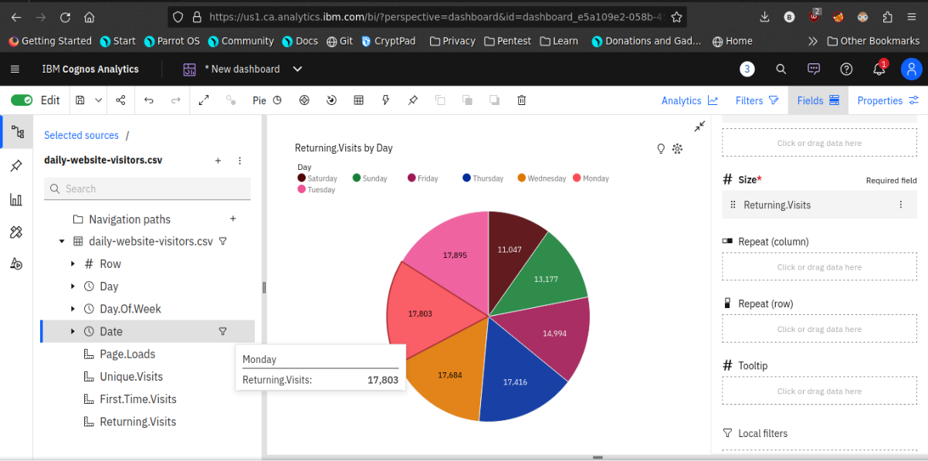

**Scatter plot**

It is used to display the relationship between two variables and observe the nature of the relationship. The relationships observed can either be positive or negative, non-linear or linear

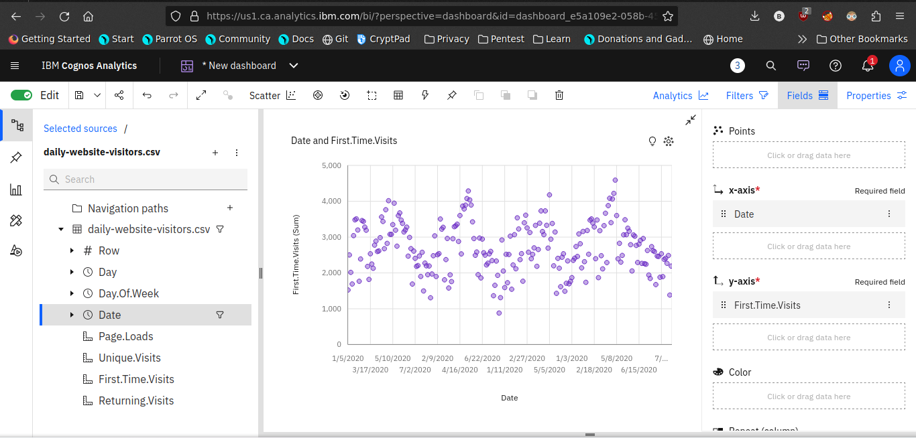

* After completing the dashboard lets export to another format

Like pdf

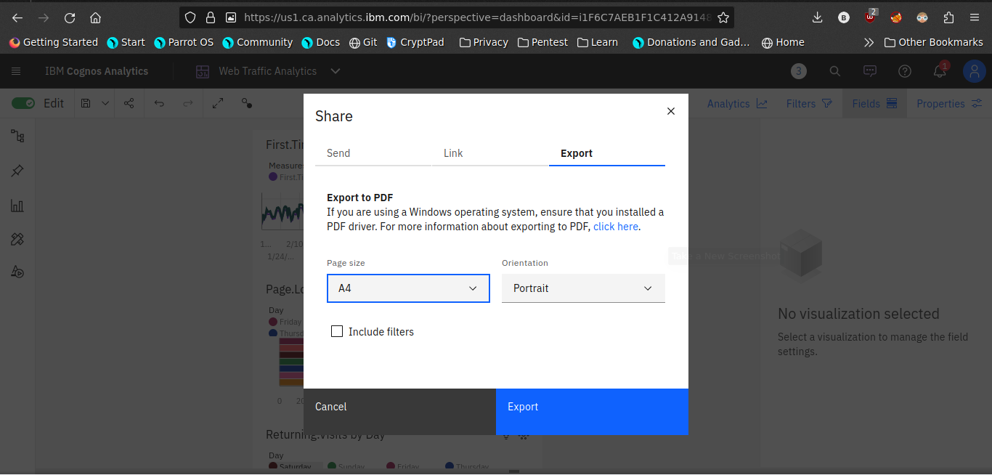

After Completing the above process the complicative report will be generated

Overall, the website traffic analysis dashboard provides website owners with a comprehensive and easy-to-use tool to analyze their website traffic and gain insights into user behavior and content performance. This information can be used to improve the user experience, increase engagement, and boost conversions.

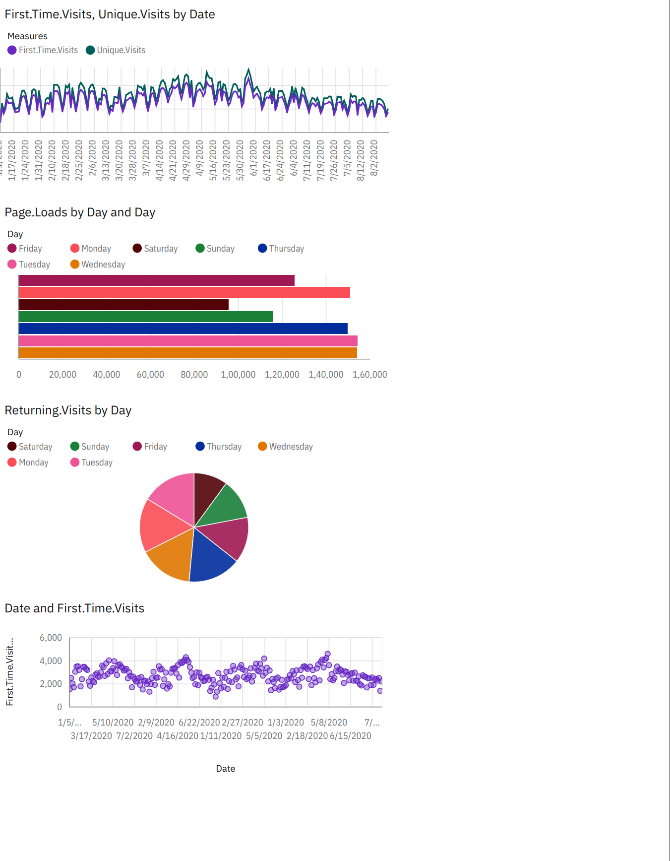

Now the visualization phase where over. lets start analyze the dataset using Python libraries use machine learning models for predictive analysis.

**Data Analysis using python**

In this steps are used to analyse the given dataset using python libraries

**Steps:**

* **Import Necessary packages**

Pandas

seaborn

Machine learning models

Linear regression

* **Make a training and test data**

Use the train test split model

Compare the testing and training data set by visualization library

* **Calculate the accuracy of the model**

Use r2_score to measure the accuracy of the model

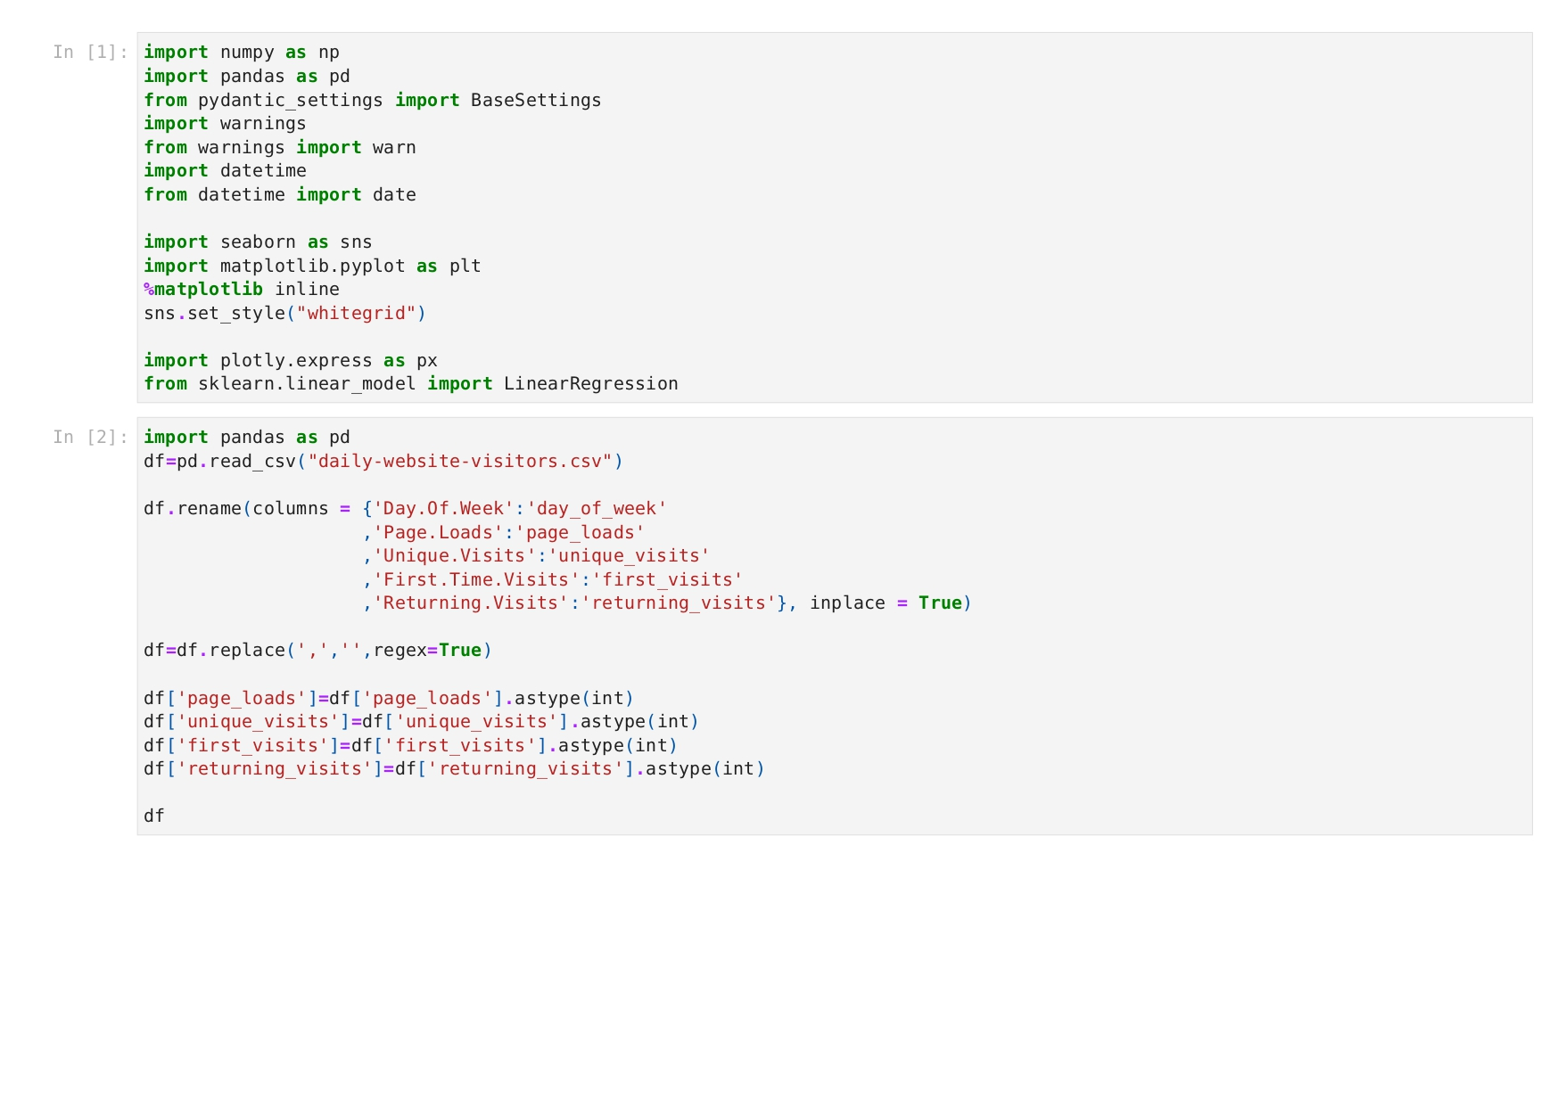

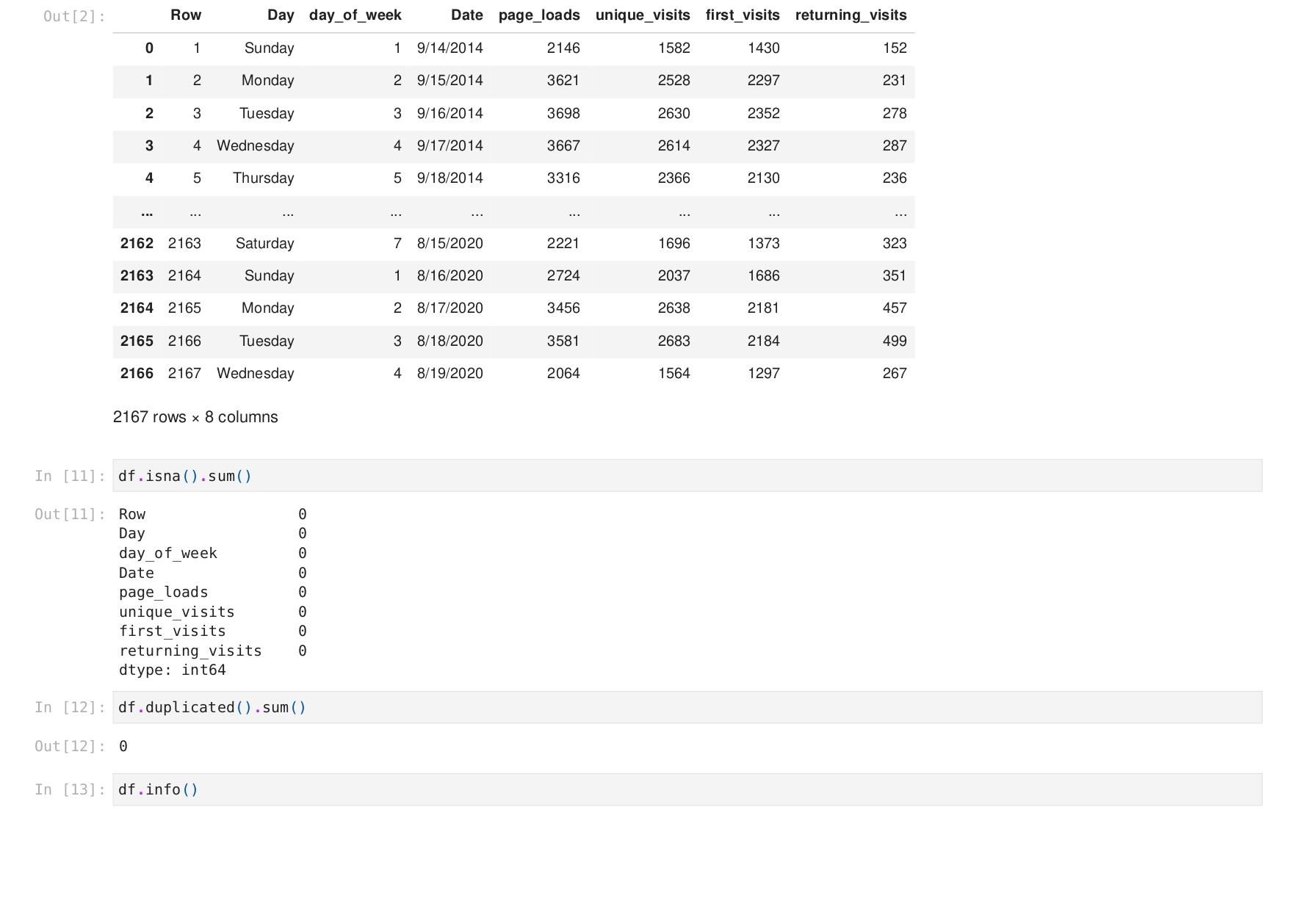

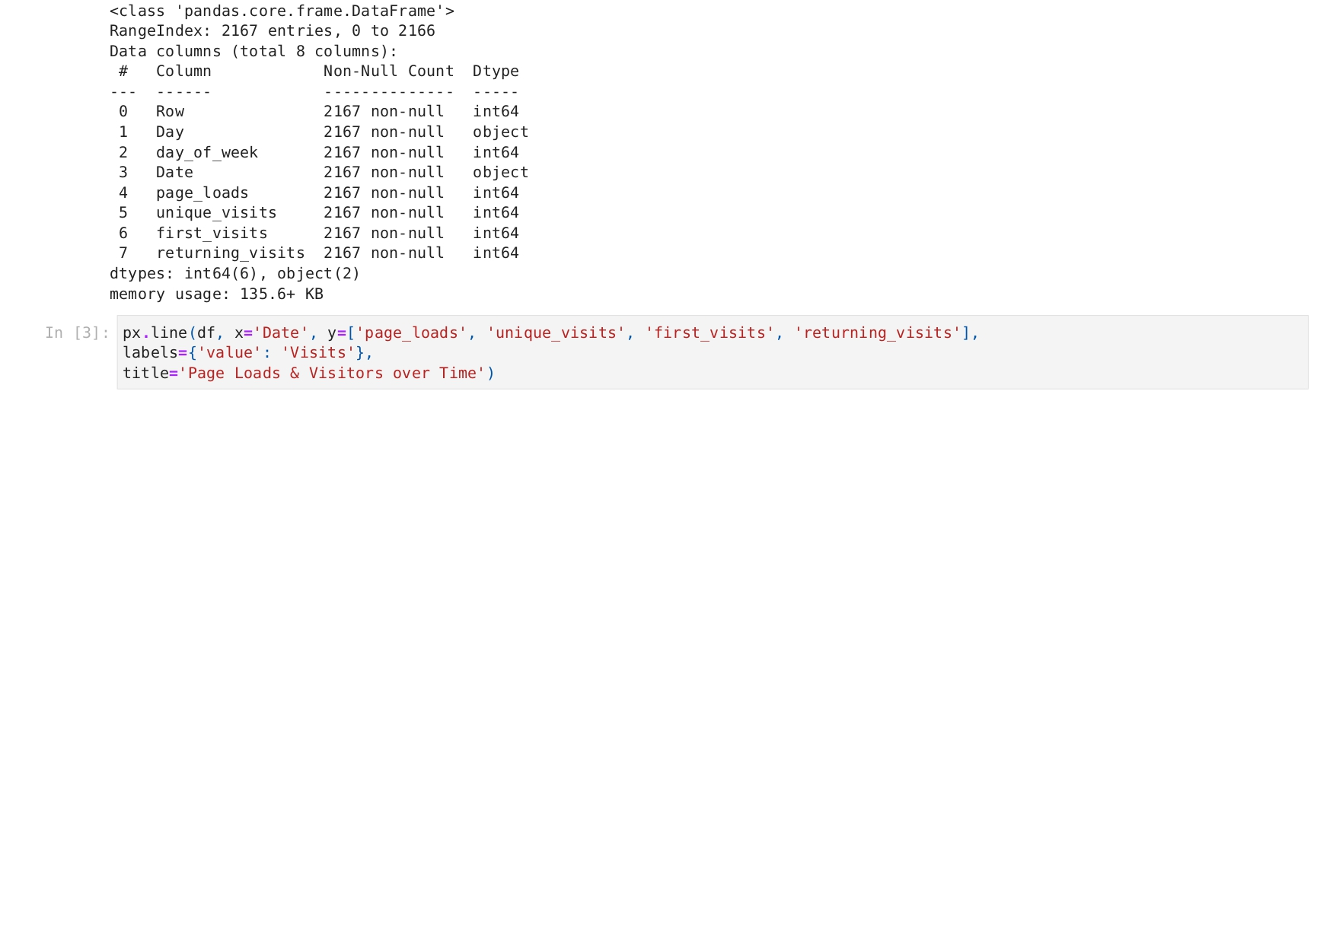

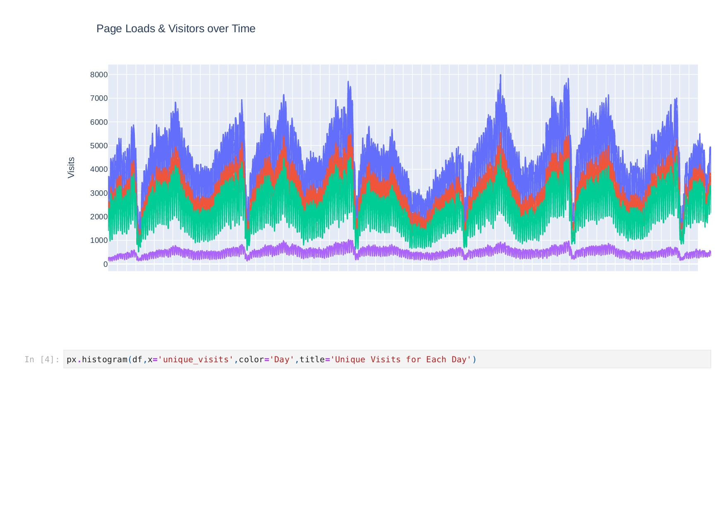

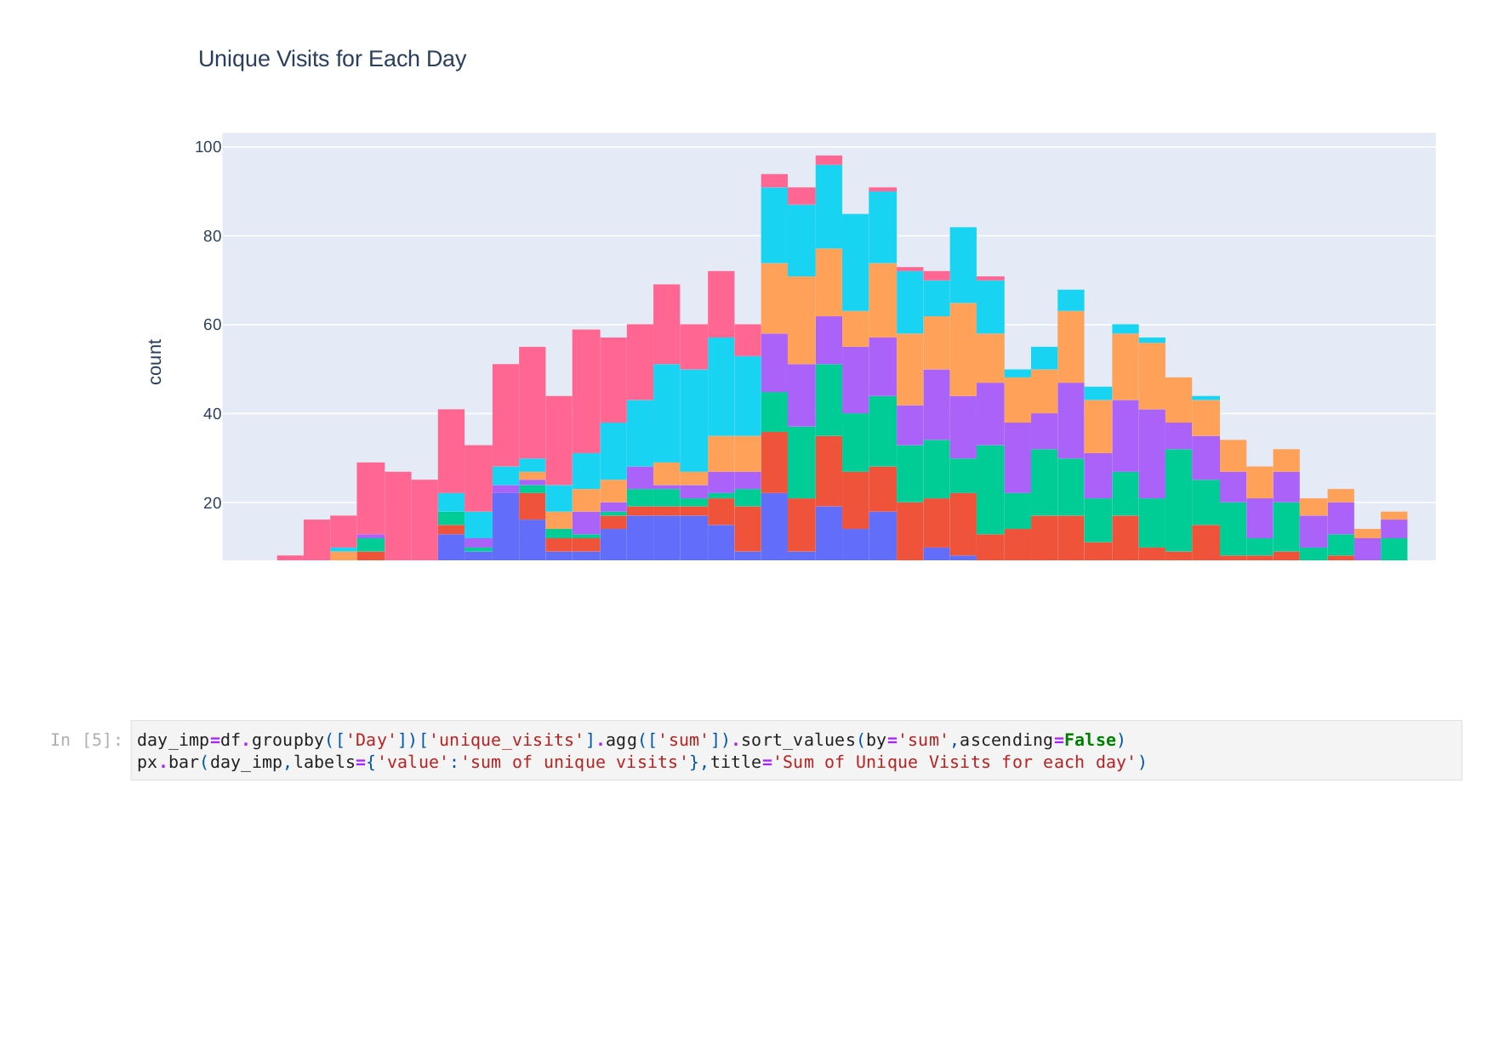

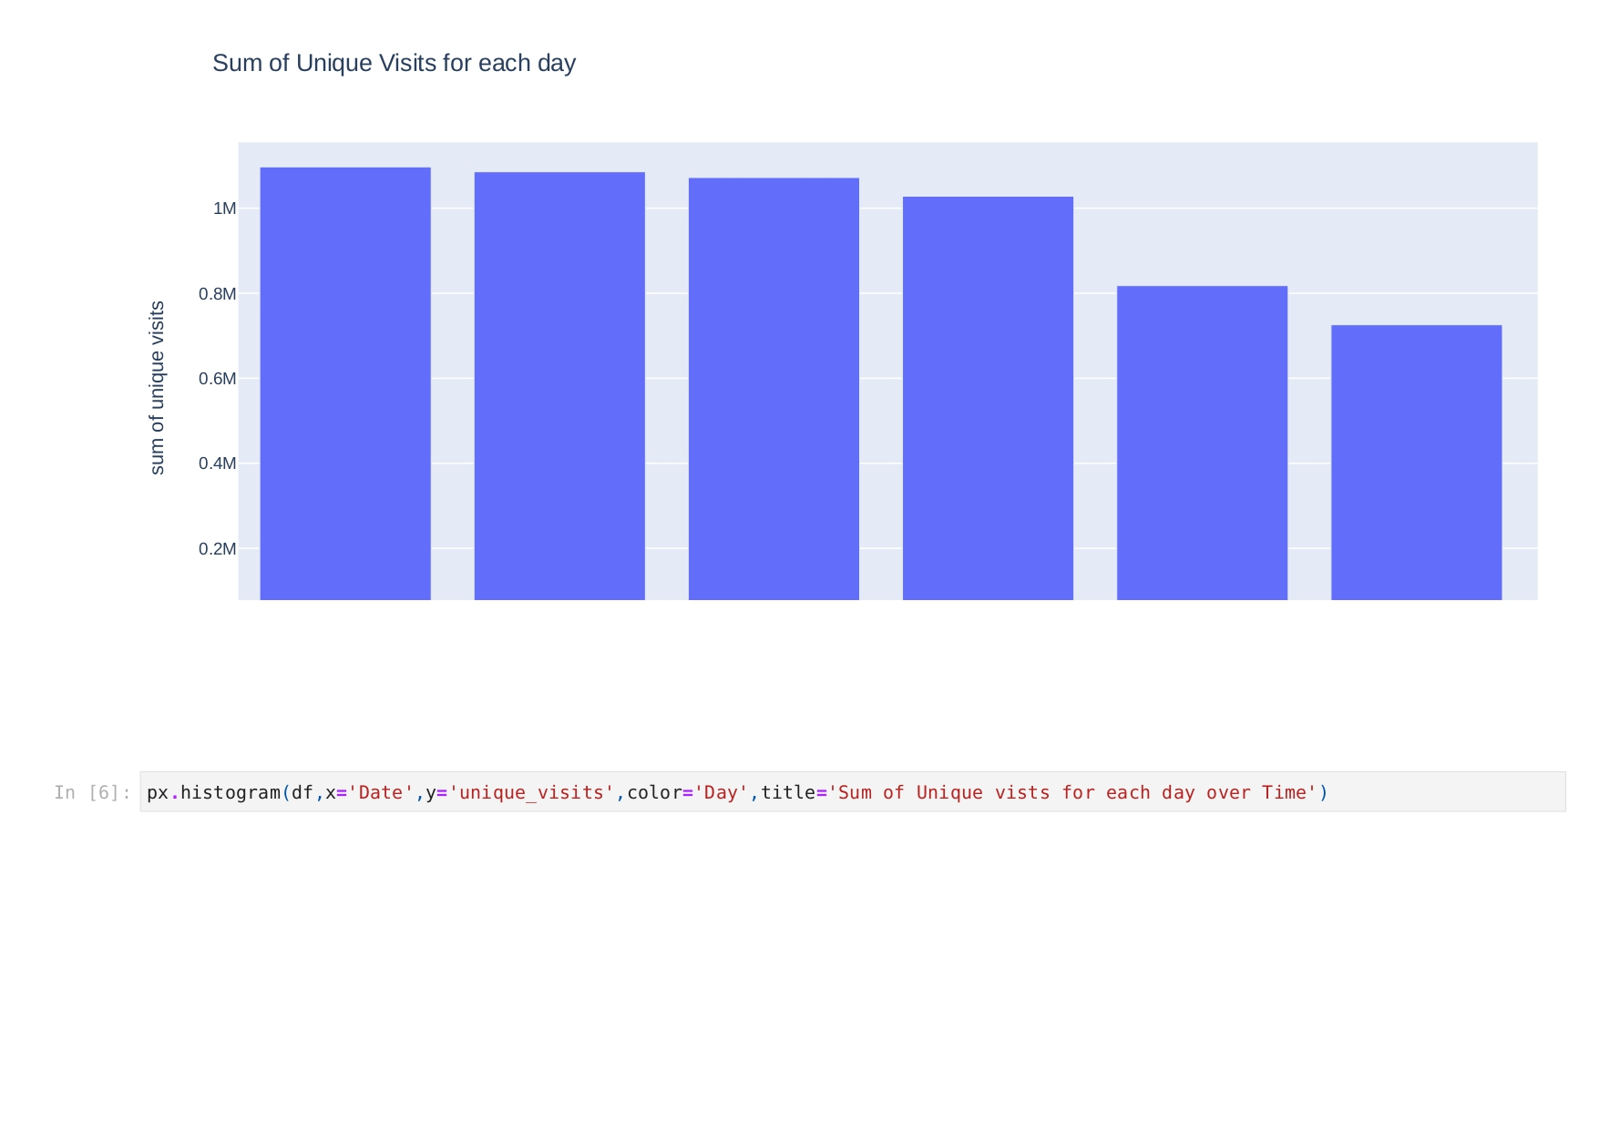

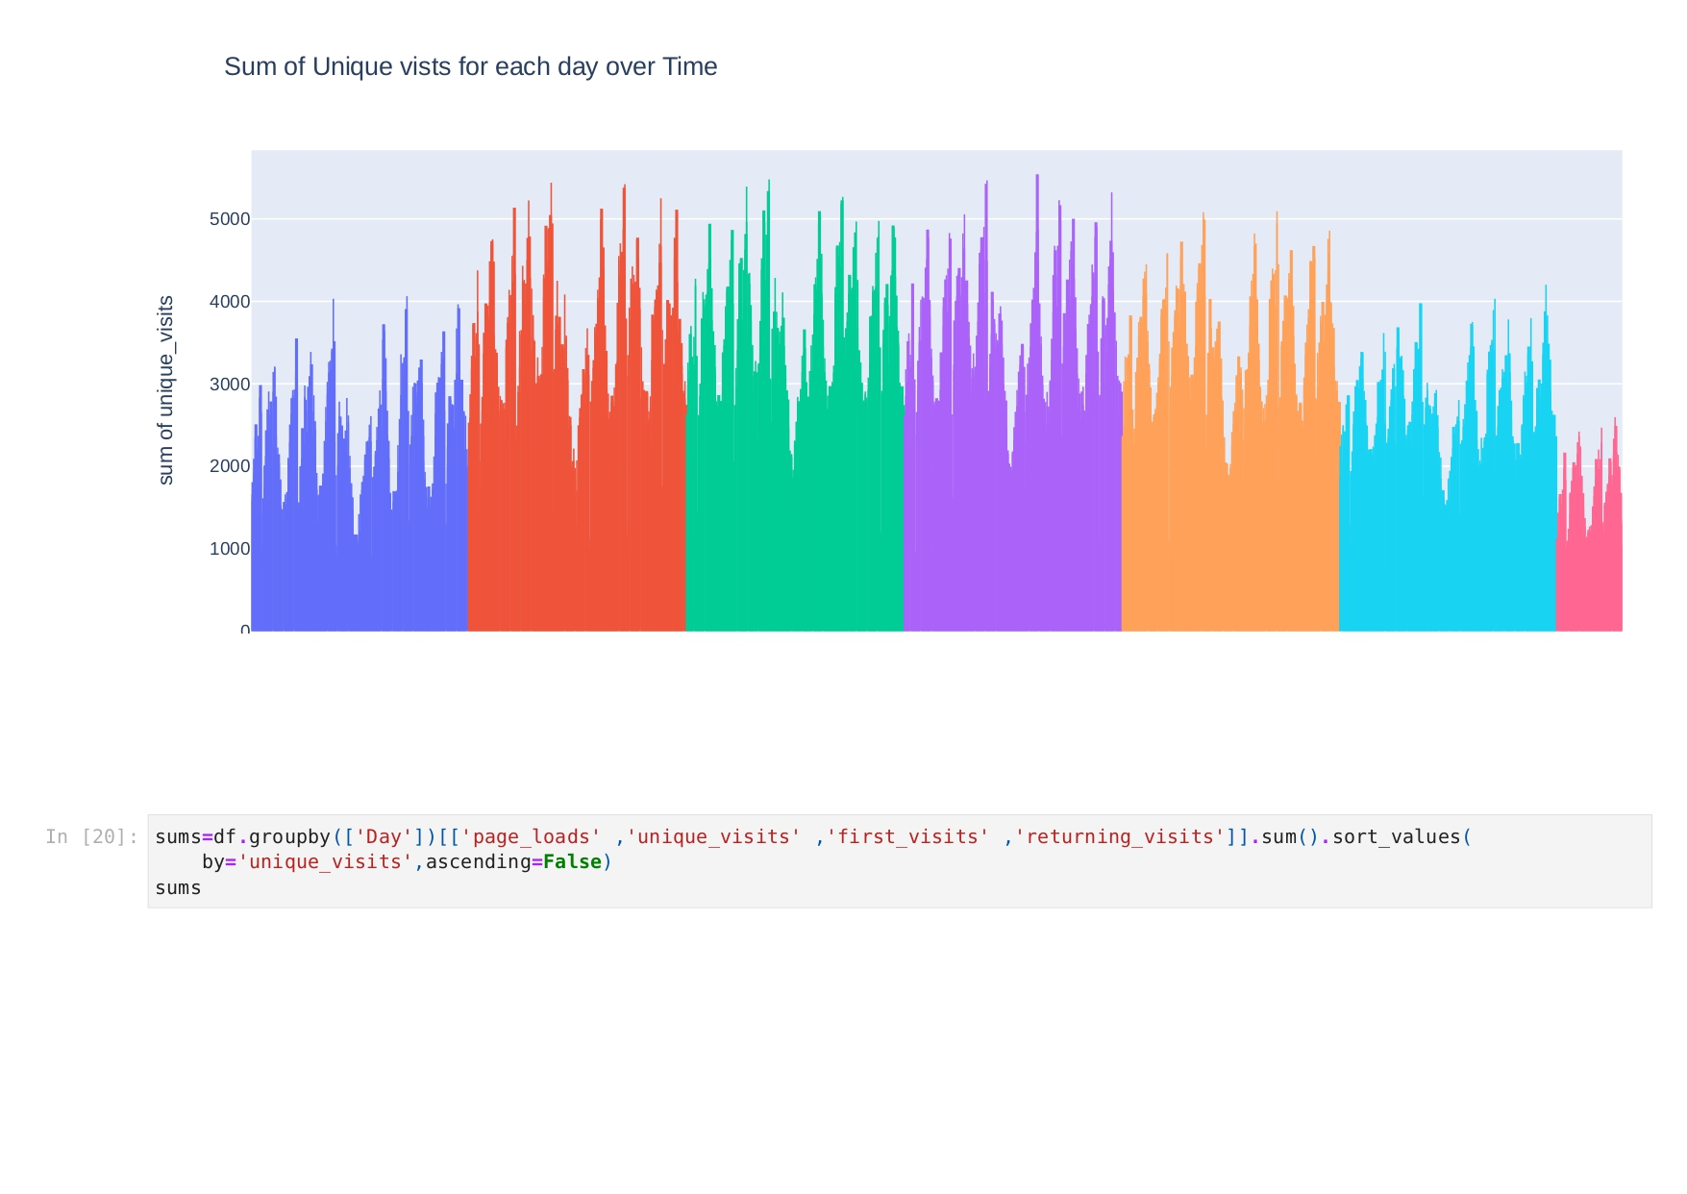

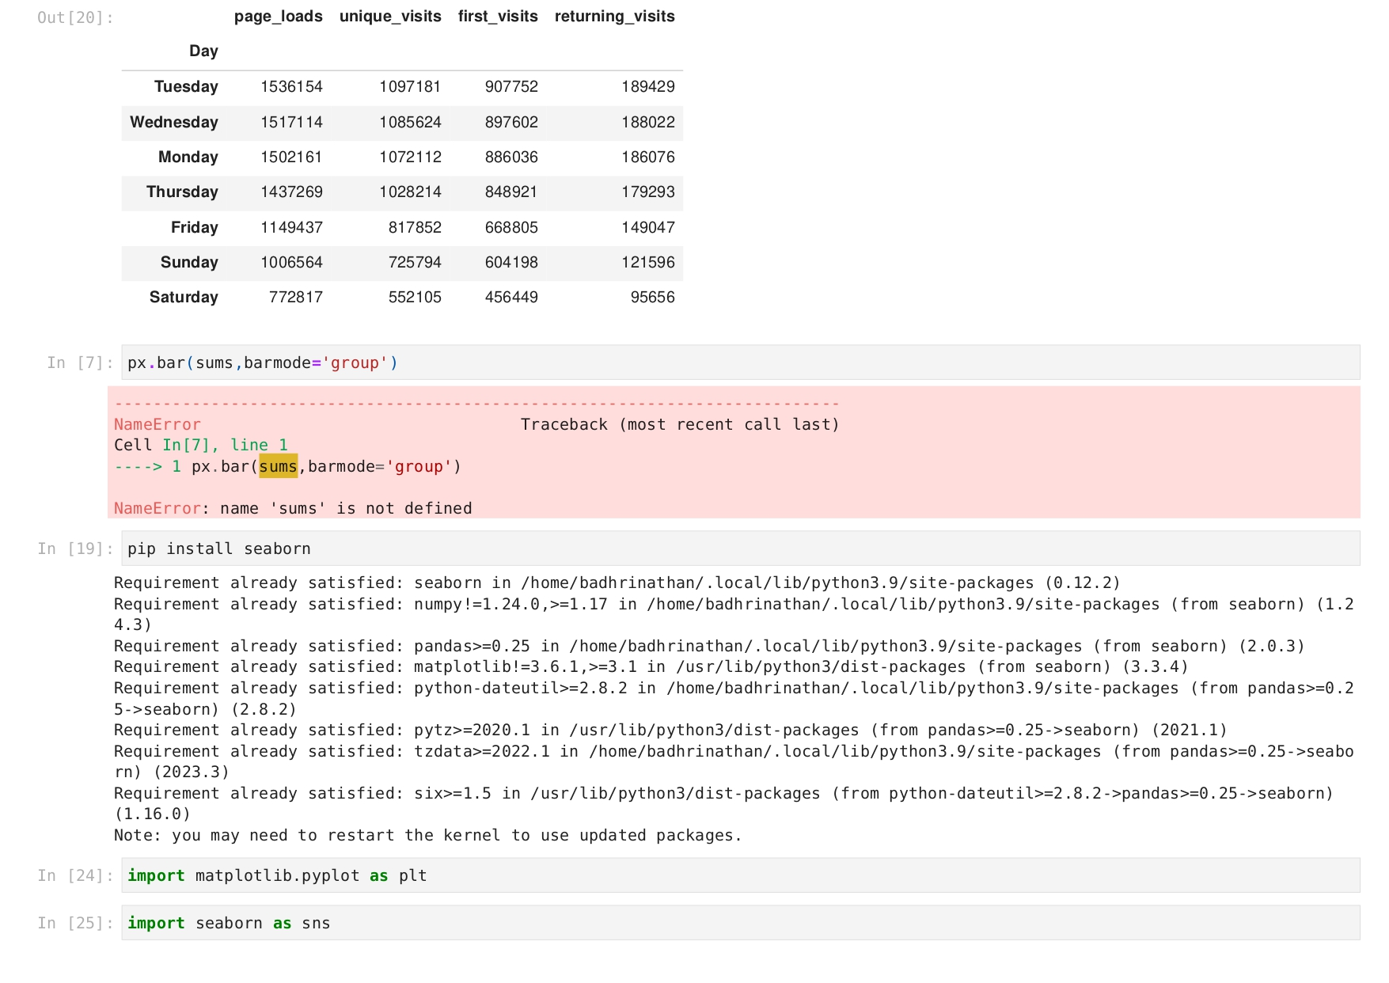

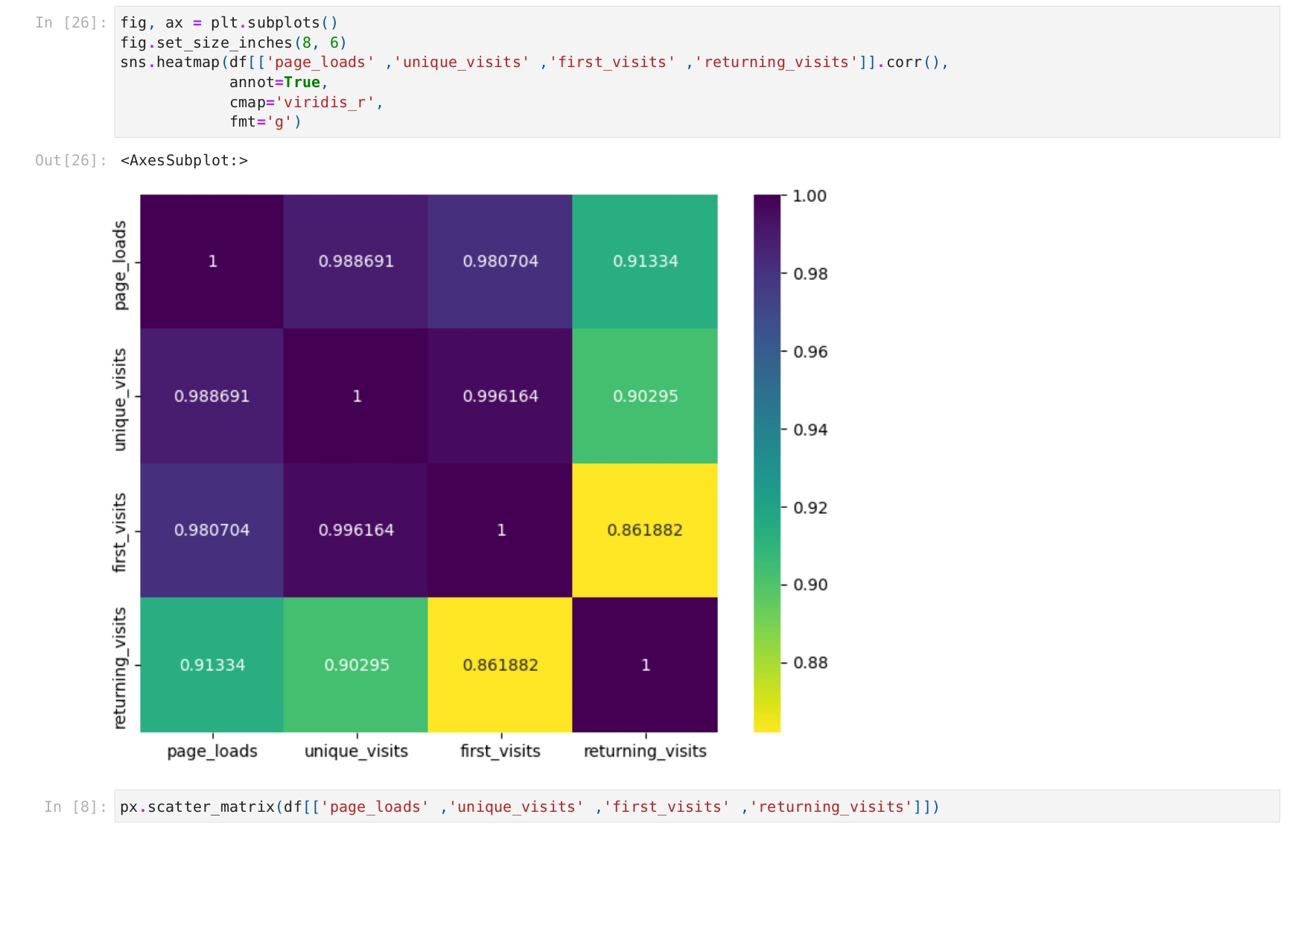

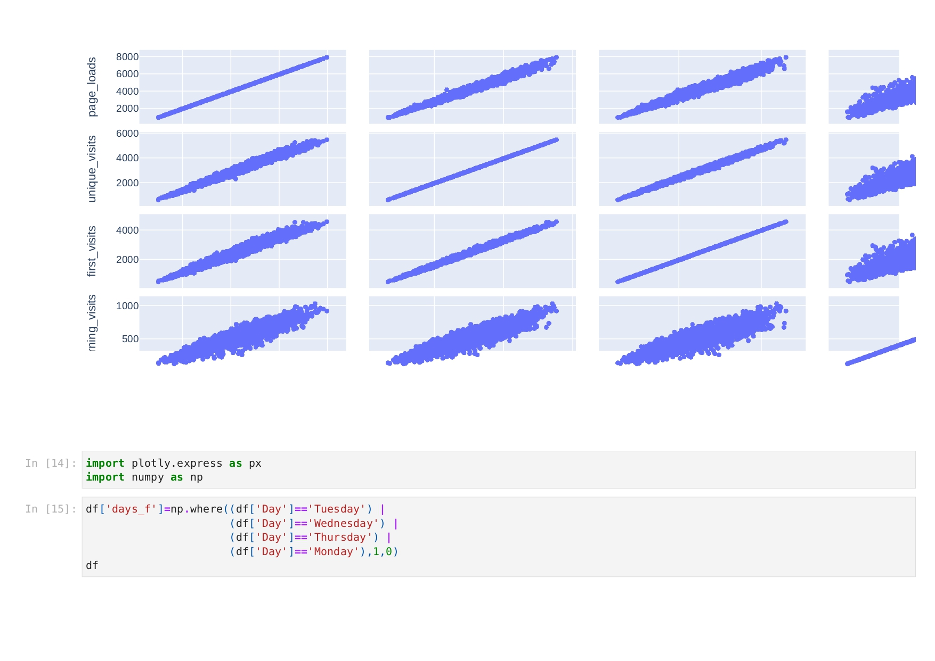

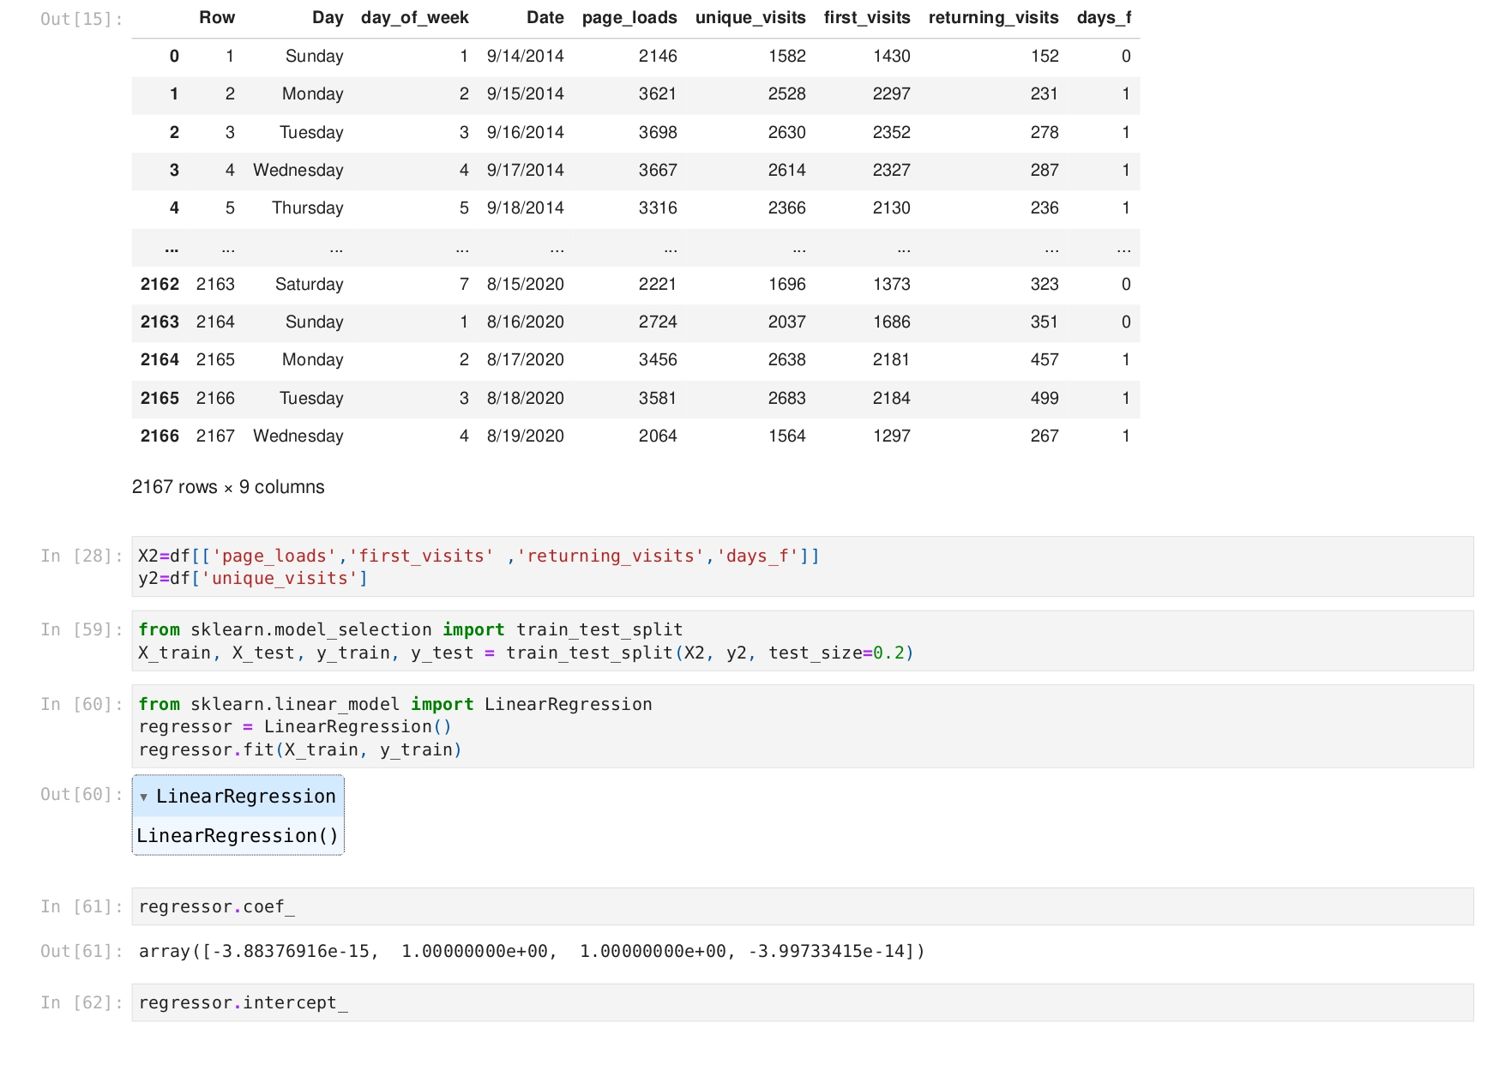

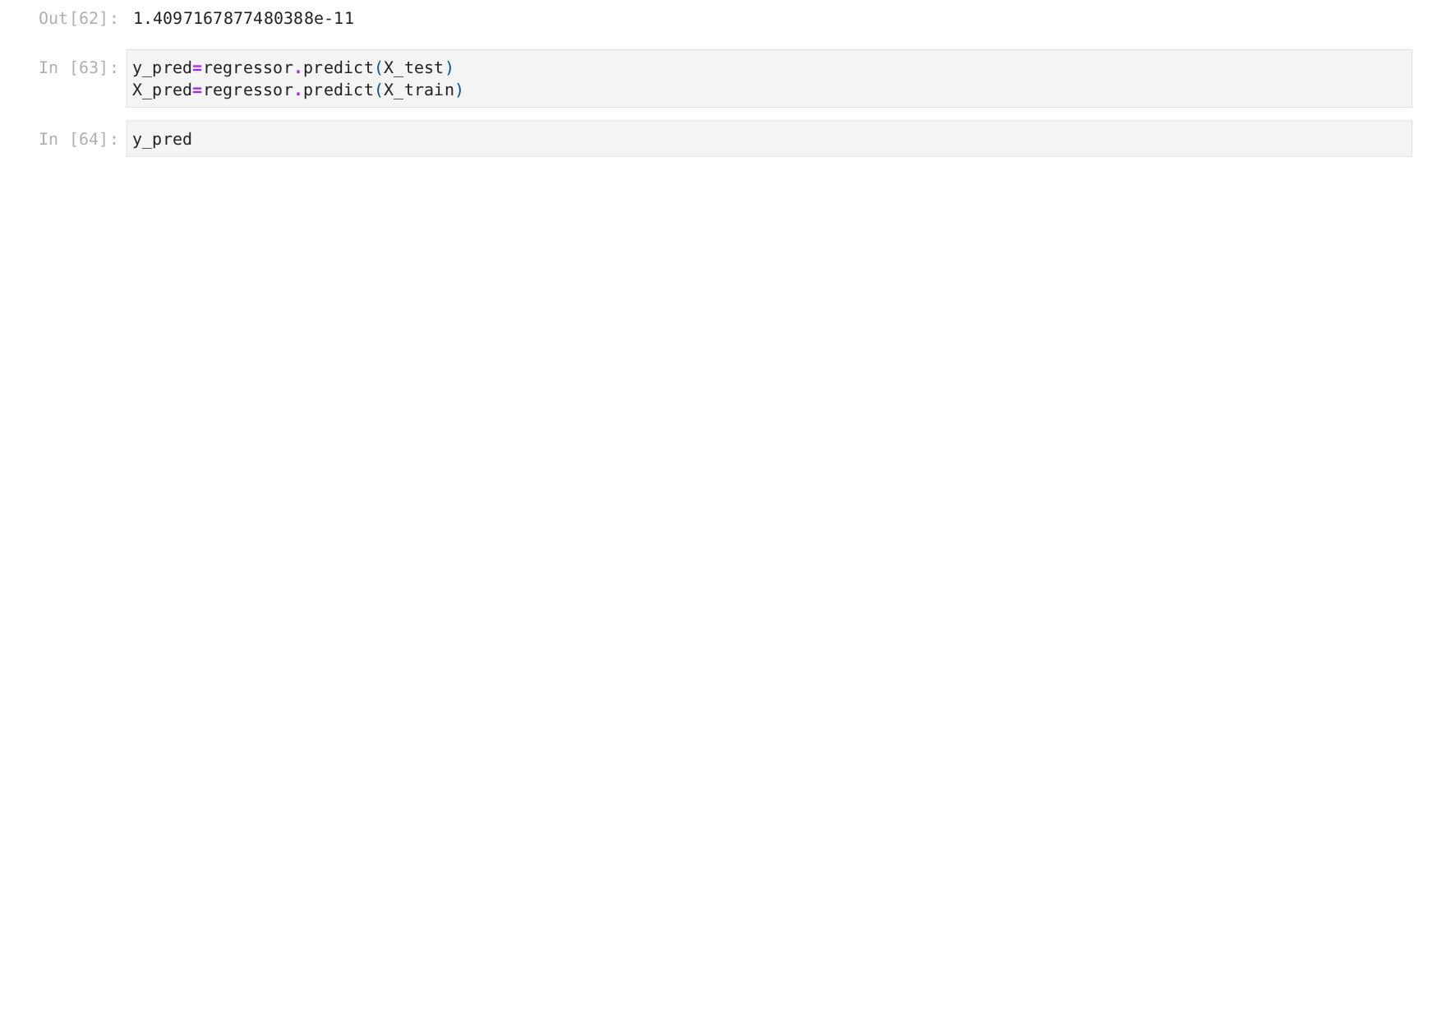





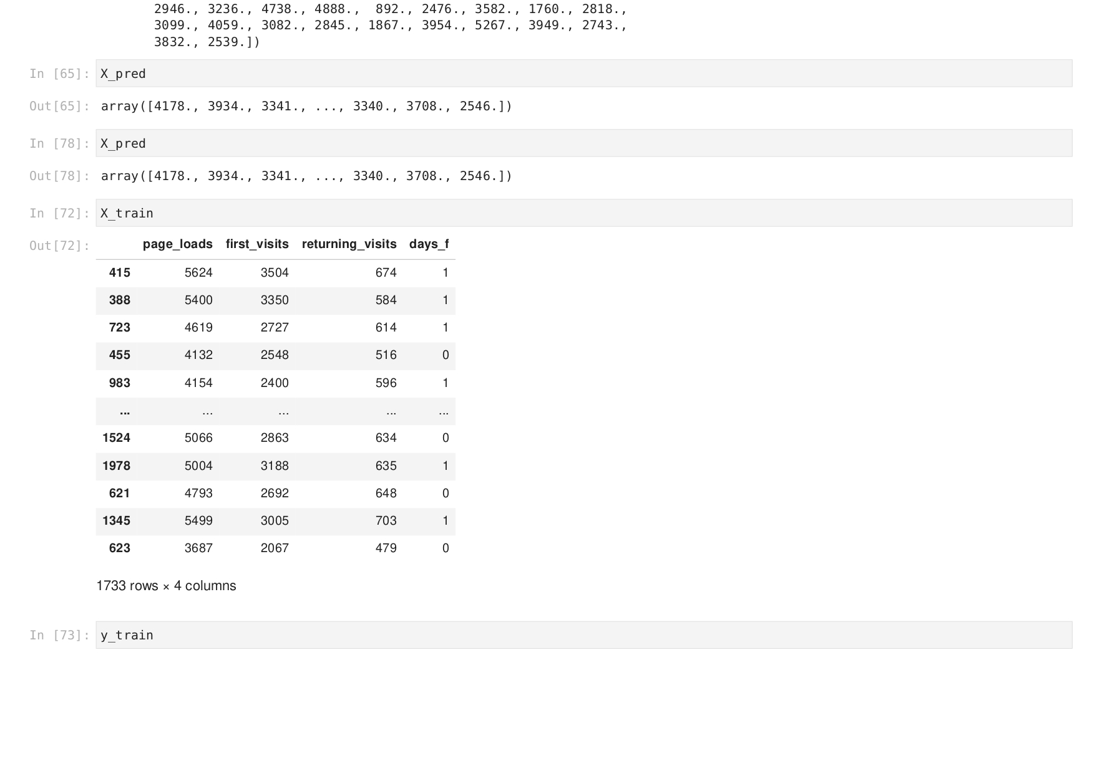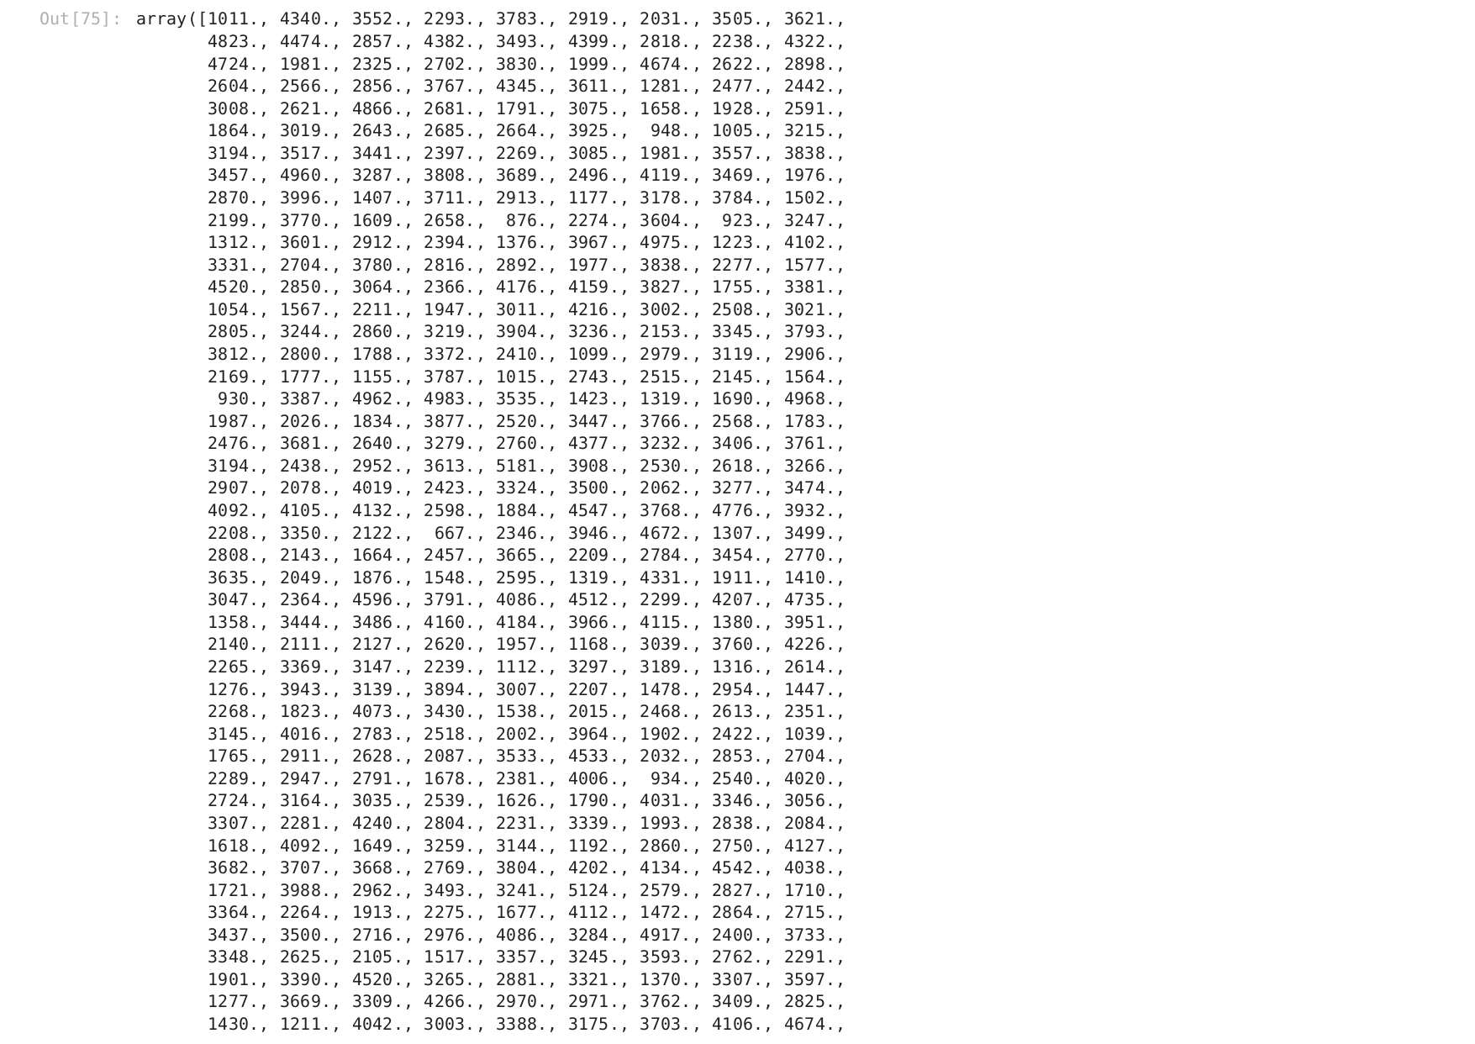

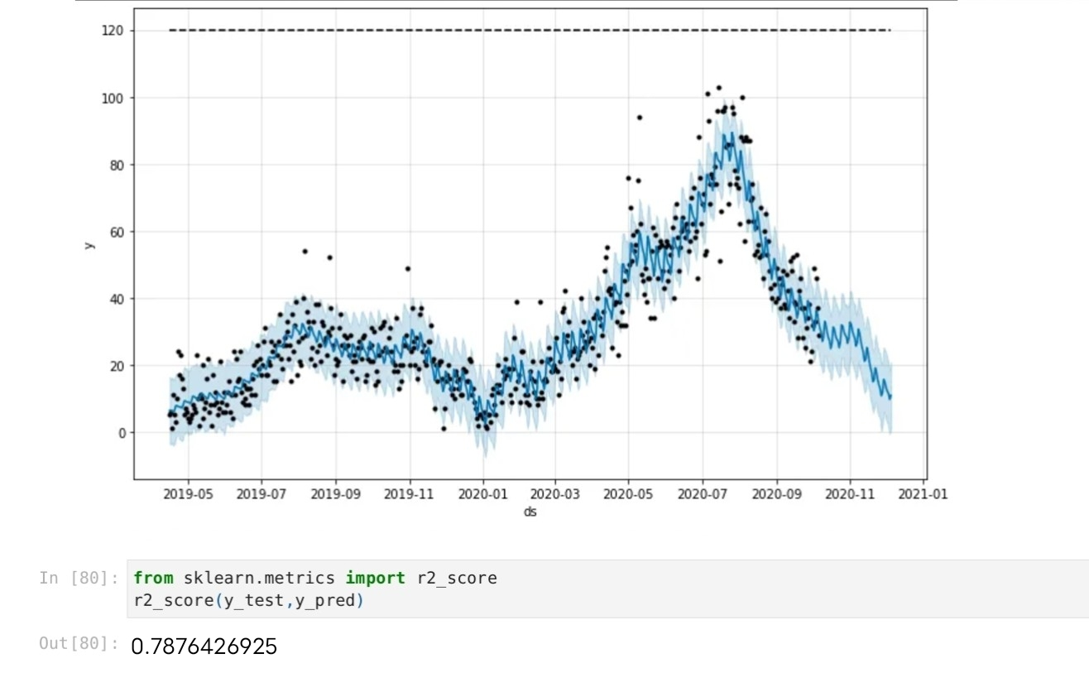

In the above asccuracy score was

0.7876426925

**Tips to** Improve User Experience:

The insights from the website traffic analysis dashboard can help website owners improve user experience in the following ways:

* Identify the most popular pages on the website and make sure that they are easy to find and navigate.
* Understand the user journey through the website and remove any obstacles that may prevent users from completing their desired tasks.
* Identify the sources of traffic to the website and focus marketing efforts on the most effective channels.
* Track the performance of different marketing campaigns and identify the ones that are most effective in driving traffic to the website.
* Measure the impact of website changes on user behavior and make adjustments as needed.

Overall, the website traffic analysis dashboard provides website owners with a comprehensive and easy-to-use tool to analyze their website traffic and gain insights into user behavior and content performance. This information can be used to improve the user experience, increase engagement, and boost conversions.

Conclusion

The website traffic analysis dashboard project was a success. The dashboard was developed using IBM Cognos and Python code integration and provides website owners with insights into their website traffic patterns, user behavior, and content performance. This information can be used to improve the user experience, increase engagement, and boost conversions.